CORE
DAY 3

Resources
2026
Morning Session

“The Vision Thing” – The Tablet 24 January 2026
…The vision, I would argue, is a "given". The vision is not ours at all, but God's vision for humanity. This is expressed in Gaudium et Spes: "God has a parent's care for every individual and has willed that all should constitute a single family treating each other as brothers and sisters" (#24). It is a vision of a revolution. It almost sounds naive, but at a moment in our history when we see the Cross raised as a symbol of division and anti-migrant protest, and the terminally ill are viewed as disposable, this vision of fraternity and care becomes a bold and risky prophetic call.
THE MISSION of the Catholic school is to help make this vision a reality. The "story" that must be told in our schools every day is the story of God's love for humanity and God's desire that we live in a new creation of peace and reconciliation, a "civilisation of love".
…Young minds and hearts require a 'mission statement that should be lived, not just laminated'…
The values flowing from this vision are the Gospel values revealed by Jesus Christ, the Word made flesh. These values find their most memorable expression in the Beatitudes (Matthew 5:1-12). Pope Francis described the Beatitudes as "like a Christian's identity card". They describe the type of person God wants us to be, liberated from the old self: open to God, loving, humble and merciful. But there is work to be done as well: justice-seeking and peace-making, which require courage.
…Schools sometimes lose their way, for all sorts of reasons, and mission drift is a real danger. At a time of a societal shift in attitudes towards human dignity, when it might seem easier just to keep your head down, mission timidity is also a temptation.
THE CURRICULUM in Catholic schools should present a "coherent and compelling expression of the Catholic understanding of reality" (CSI framework). This means that our young people should be formed in a vision of the world that is a counter-cultural story God's story which says that Creation is a gift, not a - commodity; that human beings are inherently dignified, from conception to the natural end of life, not to be judged and thrown away according to any legal status; and that our vocation as human beings is to be loving and treat others as our brothers and sisters, especially the most vulnerable, not to build walls around our own interests and communities.
Raymond Friel has spent most of his professional life in Catholic education. He is currently the CEO of Caritas Social Action Network. God's Story: The Vision, Values and Mission of a Catholic School in the Twenty First Century is published by Redemptorist Publications

Further Reading about the Catholic Identity of schools:
- Pope Leo’s Apostolic Letter “Drawing New Maps of Hope”

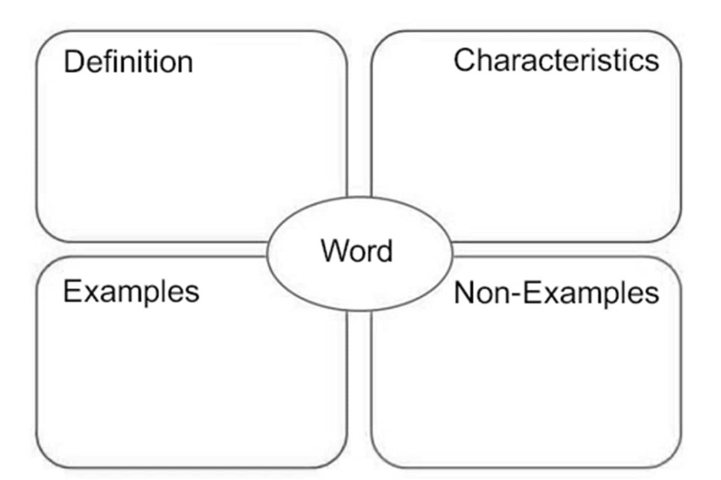
BANXXXXXXX

